Assessment - 3

Problem Statement: There can be multiple customers, who can place multiple orders on the site. Now a sales person can handle these orders will distribute into multiple sales persons (One order will be assign to one salesperson only). So a sales person can have multiple orders of multiple customers

1. Create Database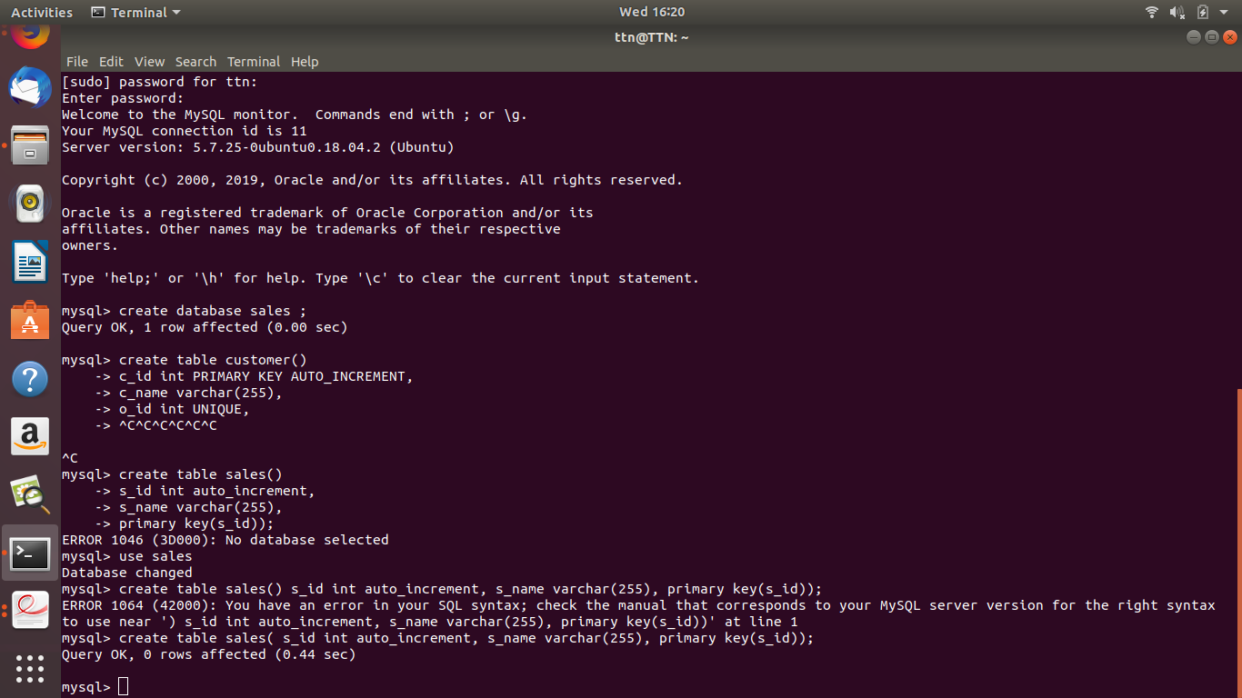

1. Design Schema

Orders

|  |  |
| --- | --- |
| O_id | Primary key |
| o_name | Order details |
| c_id | Customer id (foreign key) |
| S_id | Sales id(foreign key) |

Customer

|  |  |
| --- | --- |
| c_id | Primary key |
| c_name | customer details |

Salesperson

|  |  |
| --- | --- |
| s_id | Primary key |
| s_name | salesperson details |

1. Create tables

**Order table** - create table orders( o_id int auto_increment, o_name varchar(255), c_id int , s_id int , primary key(o_id), FOREIGN KEY (c_id) REFERENCES customer(c_id), FOREIGN KEY (s_id) REFERENCES sales(s_id));

**Customer table -**  create table customer( c_id int auto_increment,c_name varchar(255), primary key(c_id));

**Sales table -** create table sales( s_id int auto_increment, s_name varchar(255), primary key(s_id));

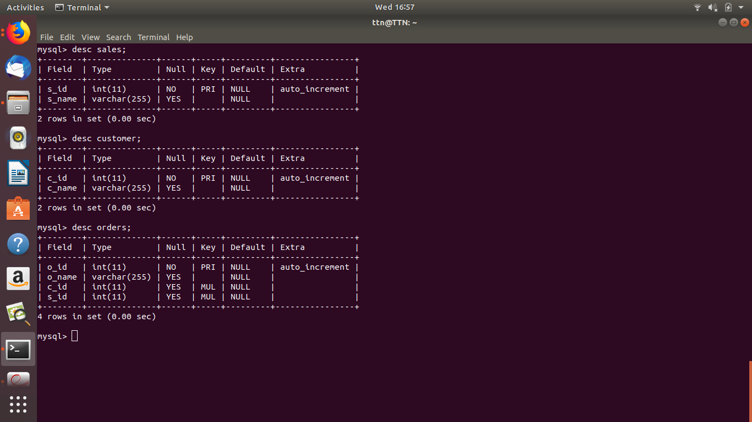

1. Insert sample data

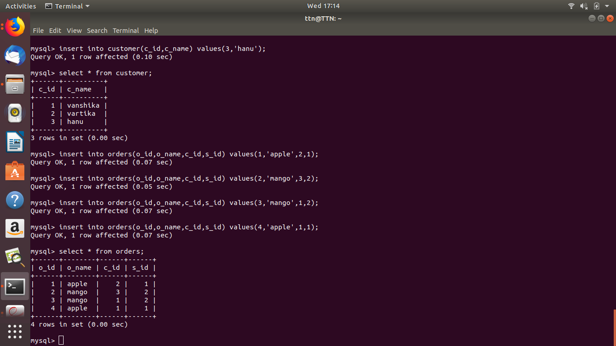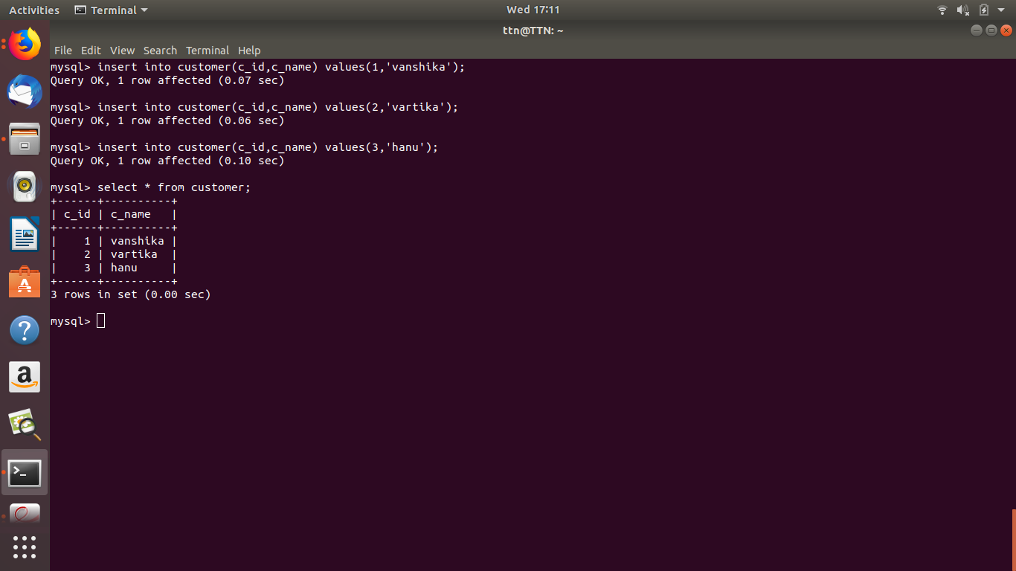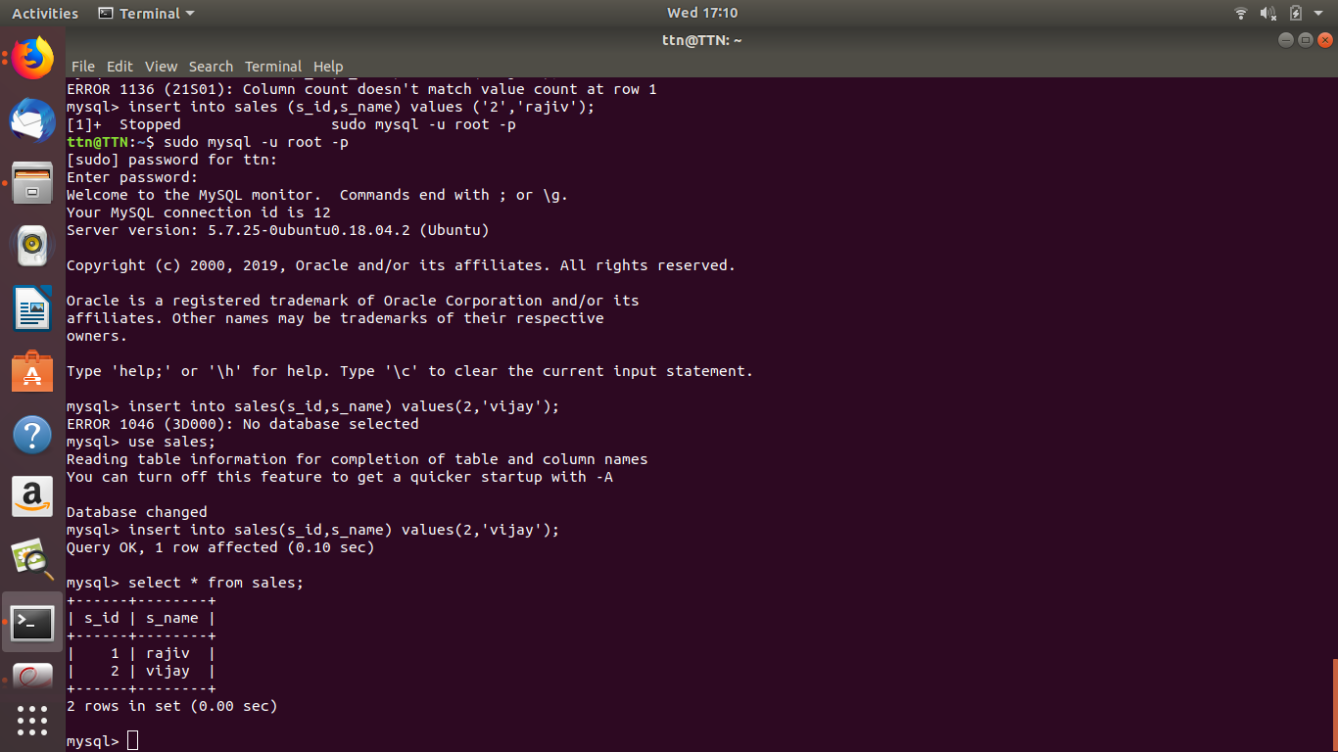

1. Find the sales person have multiple orders. - 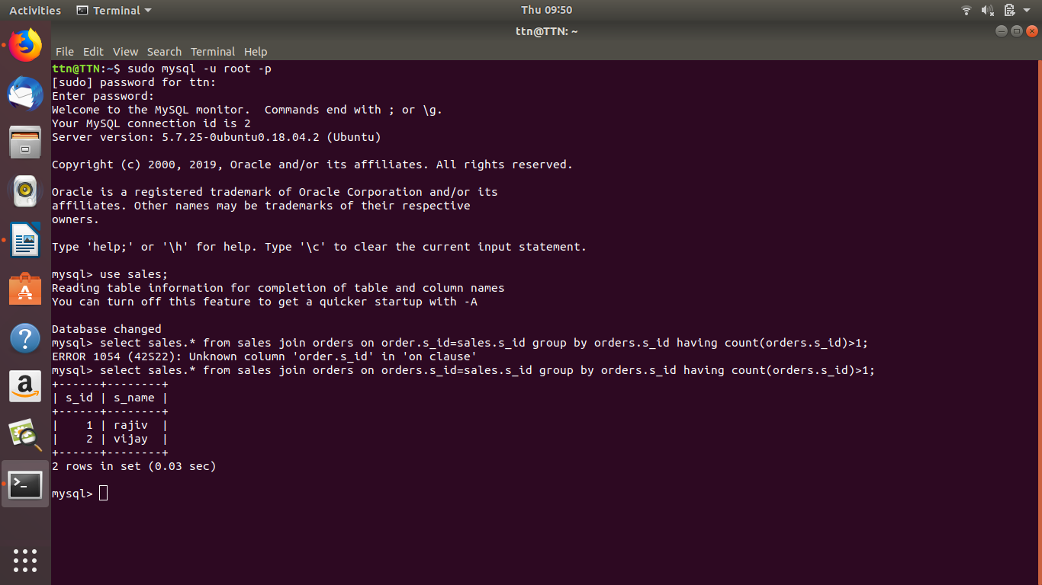

select sales.* from sales join orders on orders.s_id=sales.s_id group by orders.s_id having count(orders.s_id)>1;

1. Find the all sales person details along with order details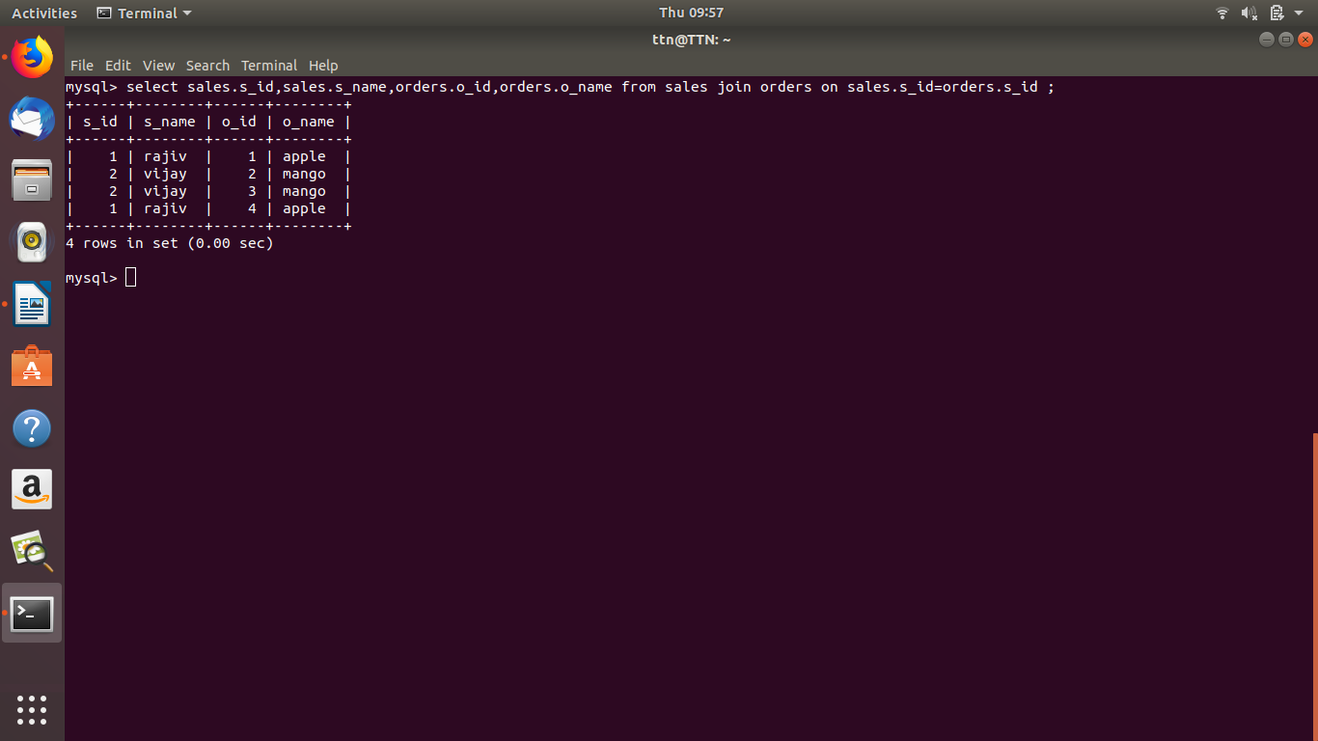
2. Create index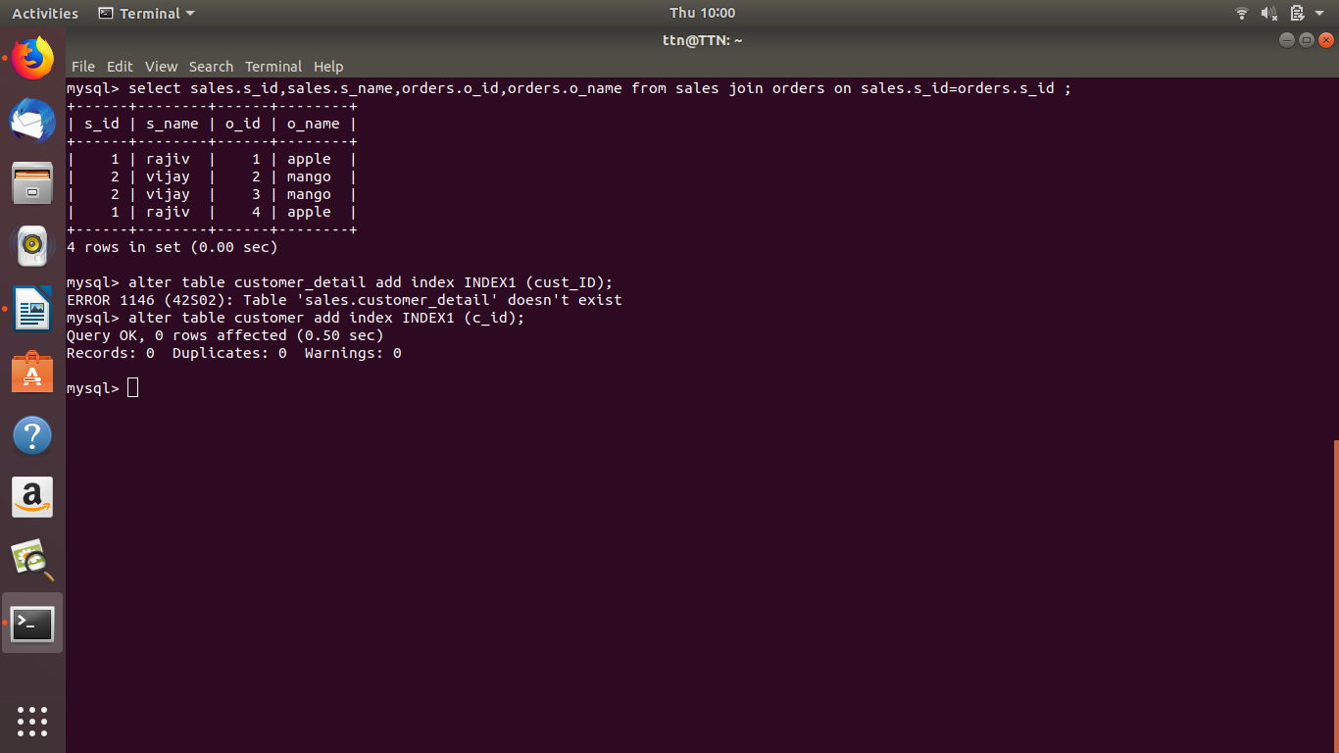

**alter table customer add index INDEX1 (c_id);**

1. How to show index on a table

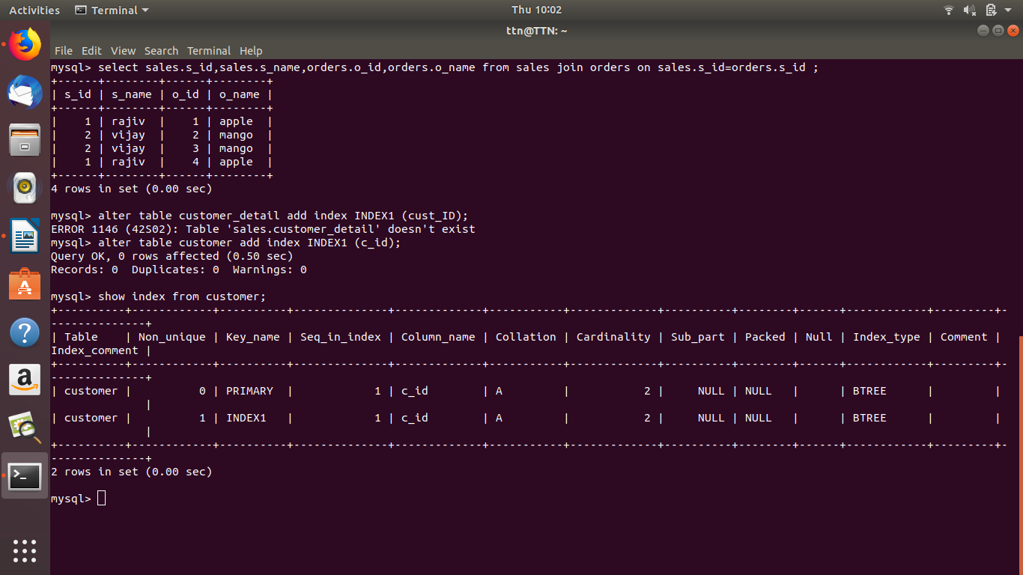

1. Find the order number, sales person name, along with the customer to whom that order belongs to

